**Lot 11 and Area Watershed**

**Management Group Inc.**

*Newsletter*

*2024/2025*

**The Lot 11 and Area Watershed Management Group is a not for profit environmental enhancement group that has been serving the Lot 11 and Central Prince Municipalities since 2009.**

**Our Mission Statement: To evaluate, enhance and preserve our watersheds so they continue to provide for the needs of our community and our environment.**

**Our Vision:**

* **A sustainable, rural community setting where residents enjoy:**
  + **Their right to clean abundant drinking water.**
  + **Freedom from intrusive or disruptive development.**
  + **Their right to enjoy and derive their living from their lands.**
  + **The respect of others for their shared resources.**

***Enhancing and engaging our community since 2009***

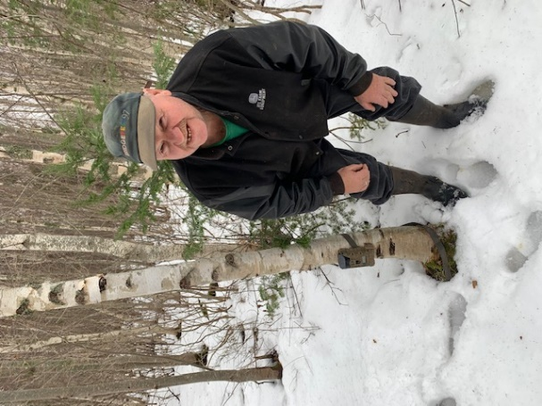

**Thank you WCF for our 2024 funding award!**

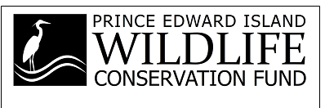

Lot 11 & Area Watershed Management Group Inc. would like to thank the PEI Wildlife Conservation Fund for funding our sediment trap excavation. Our group re-excavated a sediment trap on the Foxley River East. What does a sediment trap do? It catches sediment that’s heading downstream removing it from the stream channel and the sediment settles in the trap (hole). Every two to three years the trap is excavated and the spoils are seeded out on the property. The empty trap is ready to trap sediment once again. Pictured below are crew members temporarily closing off the trap from the actual stream allowing fish uninterrupted fish passage while the excavation process takes place. The fencing stays in place until the excavation site has settled. It’s then removed and the sediment trap is once more open for business.

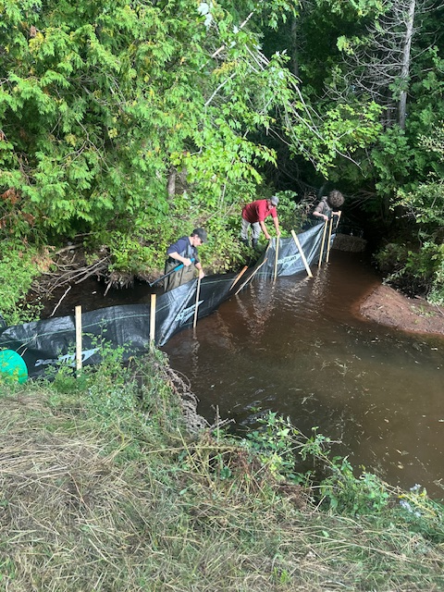

**Community-Nominated Priority Place Project**

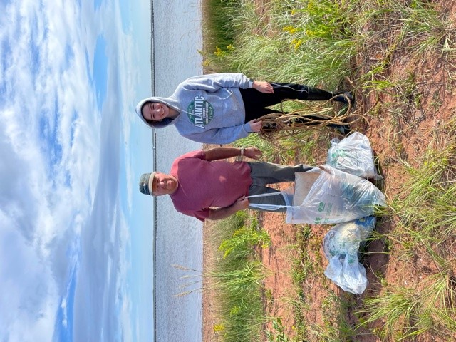**In 2024/2025 our watershed group received funding through Island Nature Trust to partner in spreading awareness of species at risk and the conflict between human use and these species in the coastal ecosystem. These uses can include transportation and infrastructure, cottage development, fishing, aquaculture, tourism and pet owners. Our goal is to work with all sectors to ensure critical habitat areas are respected with educating on the importance of ensuring beaches remain litter and debris free, leashing our pets in sensitive areas, refraining from driving ATVs or other vehicles on shorelines. This funding allowed us to conduct surveys for barn swallows in bait sheds at Milligan’s Wharf, survey our shorelines for bank swallow colonies, organized three beach cleanups along our shorelines and started important conversations with shoreline users in our area.**

**Provincial Watershed Management Funding and 2 Million Provincial Fund**

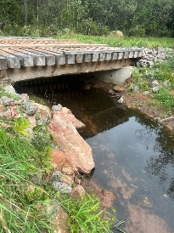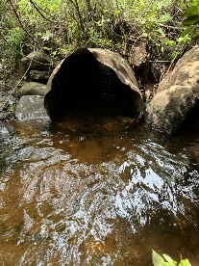**In the summer of 2024 through funding from WMF and a 2 Million Provincial Fund for special projects, our group completed:**

* **Replaced 3 major crossings on Foxley River East replacing damaged culverts with span bridges.**
* **Stream enhancement, and blockage removal**
* **Bat Surveys & Monitoring, bat house building**
* **Electrofishing surveys in major stream systems**
* **Watershed Camp 16 camps over 8 weeks**

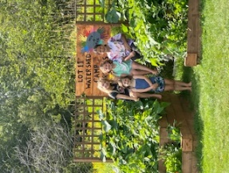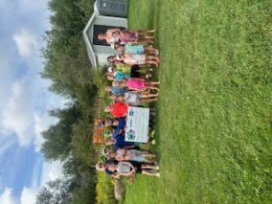

***Thank You to Win 4 All for funding watershed camp gardens and activities in 2024***

***Thank You to Employment Development Agency, Canada Summer Jobs and Skills PEI for your continued support.***

**Visit our Facebook page for more info: Lot 11 Watershed Group**